**Task 1**

Using the Query 2 you created change the points to reads times by 10 and plus 100. Record your results in your word document

Change the Query 2 code to create a discount factor so the table now shows a discount header and changing the (points + 10) *100

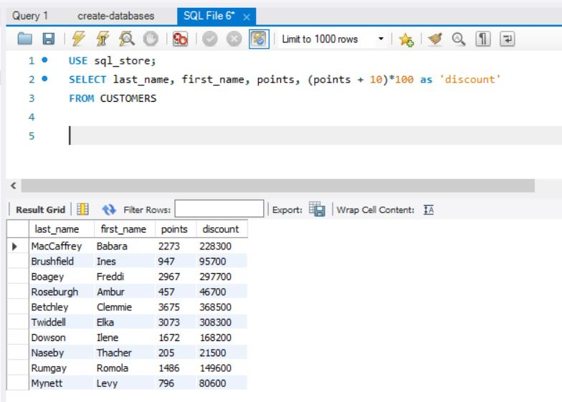

**Task 2**

Write a SQL query to return all the products in our database in the result set. I want you to show columns; name, unit price, and new column called new price which is based on this expression, (unit price * 1.1).

So, what you are doing is increasing the product price of each by 10%.

So, with the query we want all the products the original price and the new price.

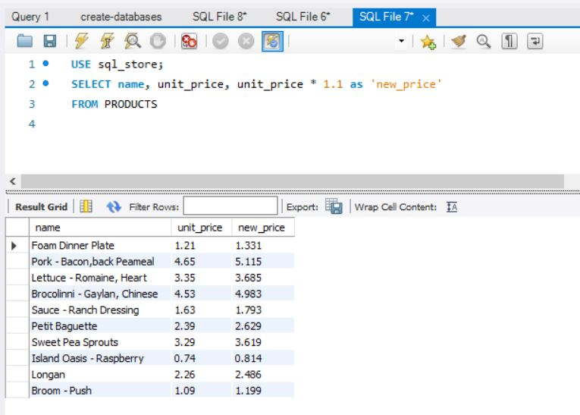

**Task 3**

In this task create a new query to find all the customers with a birth date of > '1990-01-01'

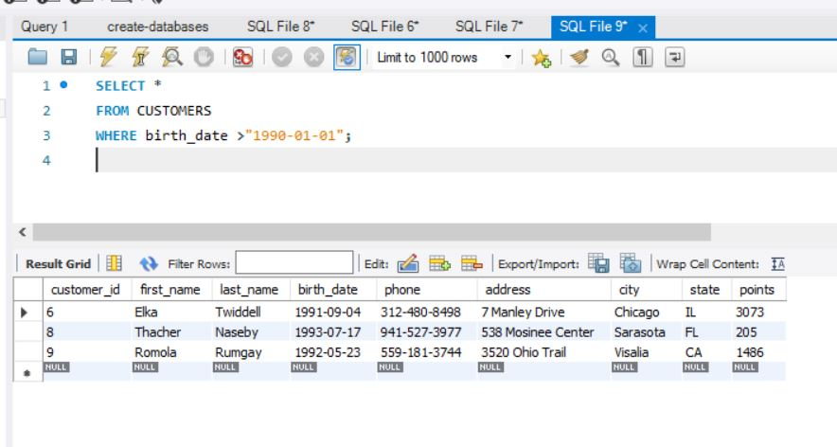

**Task 4**

Write a query to find out the name of the product with most amount in stock.

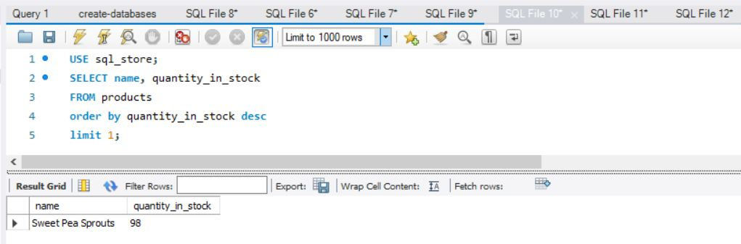

**Task 5**

Select sql_inventory.

Write a query to find out the name of the most expensive product.

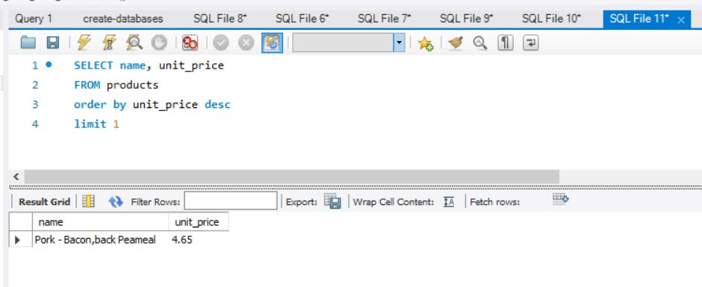

**Task 6**

Select sql_store.

Write a query to find out the first name, last name, address and the birthdate of the oldest customer.

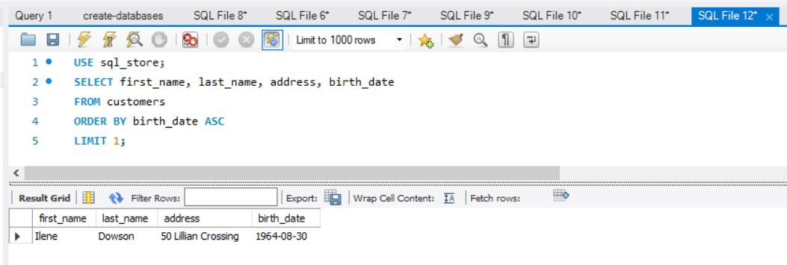

**Creating an EER Diagram**

